《英语写作（二）》课程教学大纲
一、课程基本信息
英文名称 | ENGLISH WRITING II | 课程代码 | 00041307
课程性质 | 必修课 | 授课对象 | 大学英语新生(医学院)
学 分 | 2 | 学 时 | 34
主讲教师 | 主讲教师 | 修订日期 | 2021年3月
指定教材 | 《新世纪大学英语系列教材（第二版）写作教程2》（刘海平主编）、上海外语教育出版社；美国大学英语写作（第九版）Writing Skills With Readings (Ninth Edition)
二、课程目标
（一）总体目标：
The first semester foundation skills academic writing course (Writing 1 syllabus) ends with students focusing on writing a well-structured persuasive argument, while avoiding generality, triviality and redundancy, with complex sentences, high idea density, and statements evidenced in the students’ own words.
As a natural progression, this second semester syllabus is designed to extend students understanding and practice of academic writing features, by means of an investigative research project as a term-long writing task. Ideally, this syllabus would be taught in the student's sophomore year, but that is not currently an option. In addition, should there be three semesters of academic writing, the current Writing 1 and 2 syllabus can supplemented by this author's Writing 1.5 syllabus, which is focused on extensive critical analysis in reading for responding in writing.
（二）课程目标：
The Writing 2 syllabus term-task is mainly divided into a simple research proposal document followed by a paper with four sections, with one formative and one summative assessment of each section. Students learn how to research and write in English, a simple structured investigative literature-based paper of about 3,000 words, on a specific topic that is different from classmates and from the previous year's students, that is closely related to their major.
Within the course, students are expected to learn functional language for research writing, such as tentative and connector phrases, as well as the key purposes, structures and typical content of each section of the paper. Other abilities expected to be evidenced are describing diagrams and charts, citing sources, paraphrasing and avoiding plagiarism. The processes students undertake incorporate multiple self, peer and tutor-led reflection on assignment stages, applying critical thinking and structured argument, and are intended to promote further improvement of objectivity, accuracy, complexity and significance in students' writing.
课程目标1：
•Conforming to an accepted academic research paper format (MLA) and elements (parts, sequence, logical argument, significance, etc.).
•Developing skills in sourcing and reading English language academic articles and subsequent note making for writing and referencing purposes.
课程目标2：
•Conforming to an accepted academic research paper format (MLA) and elements (parts, sequence, logical argument, significance, etc.).
•Developing skills in sourcing and reading English language academic articles and subsequent note making for writing and referencing purposes.
课程目标3：
•Conforming to an accepted academic research paper format (MLA) and elements (parts, sequence, logical argument, significance, etc.).
•Developing skills in sourcing and reading English language academic articles and subsequent note making for writing and referencing purposes.
课程目标4：
•Outlining, drafting, self-review and developing learner autonomy, whilst incorporating feedback from peers and instructor.
•Reflecting on a term long writing project experience.
课程目标5：

（三）课程目标与毕业要求、课程内容的对应关系
表1：课程目标与课程内容、毕业要求的对应关系表
课程目标 | 对应课程内容 | 对应毕业要求
课程目标1 | Critical note making:  200 word - Notes for research field and specific topic talk; Specific topic and research gap justification statement | Over the semester, students write a research paper of about 3000 words.
课程目标2 | Writing a Literature Review:  400 word - Introduction section (including method and RQs) 1st submission. | This is a specific investigation that is related to the student's major (with four main sections; Introduction, Literature Review, Discussion and Conclusion).
课程目标3 | Advanced critical writing skills:  600 word - Literature Review section 1st submission Week 11Midterm Test - 1500 words Half-paper (From cover page to end of Literature Review) | It can be experiment based, but is more likely to be literature based. Before commencing on the main project, a research proposal document needs approval from the instructor.
课程目标4 | Proofreading the entire paper:  Submission of complete 3000 word research paper (cover, contents, figures, Introduction (method, RQs), Literature Review, Discussion, Conclusion and List of References) | Students undertake incorporate multiple self, peer and tutor-led reflection on assignment stages, applying critical thinking and structured argument, and are intended to promote further improvement of objectivity, accuracy, complexity and significance in students' writing.
三、教学内容
第一单元：Critical note making
1.教学目标：
Introduction to instructor, course and scientific research writing (ppt). Model research paper. Review of previous semester's writing skills, initial researching, topic talk note making, four parts to justifying a research topic and interrogating a topic statement model.
- 教学重难点：
Four parts to justifying a research topic and interrogating a topic statement model.
- 教学内容：
Syllabus and assignments stages, due dates and basic criteria. Narrowing and critiquing a topic, forming meaningful RQs, critical note making, turning a topic talk into a research proposal (modeled on ppt). How to write an Introduction section (part
- 教学方法
Interaction and inspiration between Teacher and Students
- 教学评价
Comments on excellent model articles.Check students' classroom participation; pay attention to the evaluation of students' innovation ability, critical thinking ability

第二单元：Writing a Literature Review
- 教学目标：
How to write a Introduction section (part 2), without information gaps. Introduction section writing tutorial. Method sub-section writing. Approval and advising on submitted research proposals.
- 教学重难点：
Approval and advising on submitted research proposals.
- 教学内容：
Tutorial class to self and peer improve Introduction, using worksheets and class / one to one discussions;
Advanced critical writing skills; analyzing argument (structure consistency /validity/assumption/etc.) Various written tasks to prove understanding of key elements of critical reading for discussion writing
- 教学方法
Interaction and inspiration between Teacher and Students
5. 教学评价
Comments on excellent model articles.Check students' classroom participation; pay attention to the evaluation of students' innovation ability, critical thinking ability

第三单元： Advanced critical writing skills
- 教学目标：
Writing a Literature Review. Model LR's. Structural organization choices. Language to compare/contrast/differentiate researched sources. Organizing sources. Searching online. Avoiding citing Wikipedia. Plagiarism. Elements of discussion writing, Findings / Discussion writing, group discussions models, model interrogation worksheet and outline worksheet.
- 教学重难点：
Searching online. Avoiding citing Wikipedia. Plagiarism
- 教学内容：
Diagrams. Working with data. Language for describing experiments/ charts / diagrams, etc. Tutorial class for writing a Literature Review section. Tutorial class for writing a Discussion section.
Writing propositions, supporting arguments, intermediate, summative and logical conclusions, writing limitations, improving titles. Model Conclusion.
Elements of discussion writing, Findings / Discussion writing, group discussions models, model interrogation worksheet and outline worksheet.
- 教学方法
Interaction and inspiration between Teacher and Students
5. 教学评价
Comments on excellent model articles.Check students' classroom participation; pay attention to the evaluation of students' innovation ability, critical thinking ability

第四单元：Proofreading the entire paper
- 教学目标：
Self and peer review worksheets for checking Literature Review quality. Problem solving class discussion. Tutorial class on writing a conclusion section. Self and peer review worksheets. Writing the List of References section and Abstract.
- 教学重难点：
Problem solving class discussion. One-to-one interviews, aimed at improving each student's final paper.
- 教学内容：
- Class and individual discussions of returned Literature Reviews. Reviewing half-paper requirements tutorial.
- Reviewing, improving and proofreading the entire paper.
- Week 17. Final Exam - Full paper submission. Submitting a no plagiarism declaration. Prompts for writing a course reflection and learning progress essay
4.教学方法
Interaction and inspiration between Teacher and Students
5. 教学评价
Comments on excellent model articles.Check students' classroom participation; pay attention to the evaluation of students' innovation ability, critical thinking ability
四、学时分配
表2：各章节的具体内容和学时分配表
章节 | 章节内容 | 学时
第一单元 | Critical note making | 8
第二单元 | Writing a Literature Review | 8
第三单元 | Advanced critical writing skills | 8
第四单元 | Proofreading the entire paper | 10
五、教学进度
表3：教学进度表
周次 | 日期 | 章节名称 | 内容提要 | 授课时数 | 作业及要求 | 备注
1-4 | 3.8-3.29 | 1 | Critical note making | 8 | Written submission
5-8 | 4.5-4.26 | 2 | Writing a Literature Review | 8 | Written submission
9-12 | 5.3-5.24 | 3 | Advanced critical writing skills | 8 | Written submission
13-17 | 5.31-6.28 | 4 | Proofreading the entire paper | 10 | Written submission
六、教材及参考书目
1. Science Research Writing - A Guide for Non-native Speakers, H. Glasman-Deal,
Imperial College Press, 2010
- The St. Martin's Handbook, 7th Edition, A.L. Lunsford,
Bedford/St. Martins 2011.
七、教学方法
Teaching methods are based on TBLT but with earlier setting of the ultimate production goal. Most lessons begin with showing clear lesson goals, followed by raising interest, after which key functional knowledge is provided by ppt, supported by handout model texts, stage tasks and group and class discussion. Most lessons end with reviewing whether each student feels they have met the intended learning goals, before a homework assignment is issued, to confirm such learning.
In the first half of the course, most of the course input is by ppt, teacher explanation, discussion, model texts and worksheets. Handouts with enhanced text and side notes of key features are used throughout, to foster greater interaction with input. In class worksheets were used to ensure students interrogated model texts. Extensive blackboard presentation is used as a summary device and to aid in providing flexible input that can respond quickly to apparent student problems.
In the second half of the course, in-class tutorial time is increasingly introduced, as well as one-to-one discussions and voluntarily out of class ‘clinic’ times. Students are encouraged to start researching early and to keep a structured research notebook from the course beginning. Incidentally, classroom rules, such as no sleeping, messaging or doing other subject work, are made clear on day one and firmly enforced throughout the course. Students bring their laptop to each class, with use only allowed outside teacher presentation times.
Instruments include: a review worksheet of writing 1 syllabus's key points, which is followed by weekly input via presentations, worksheets for students to interrogate models, open class analysis of model texts, worksheets to structure students thinking, planning and writing, worksheets to support self and peer review, class questions and discussions, one-to-one tutorials, online and after class additional support, explicit coded and strategic formative assessments, summative assessments by classwork and extended project exams. Finally students are guided to complete a reflection of learning and of the course inputs and goals.
Key classroom strategies include close monitoring of student participation in the staged tasks by moving around the classroom, asking and answering student questions during tutorial times, and by formative assessment of tasks.
八、考核方式及评定方法
（一）课程考核与课程目标的对应关系
表4：课程考核与课程目标的对应关系
课程目标 | 考核要点 | 考核方式
课程目标1 | Critical note making | closed
课程目标2 | Writing a Literature Review | closed
课程目标3 | Advanced critical writing skills | closed
课程目标4 | Proofreading the entire paper | closed
（二）评定方法
1．评定方法
平时成绩：30%，期中考试：20%，期末考试50%
2．课程目标的考核占比与达成度分析
表5：课程目标的考核占比与达成度分析表
考核占比  课程目标 | 平时 | 期中 | 期末 | 总评达成度
课程目标1 | 5% | 5% | 10% | 100%  分目标达成度={0.3ｘ平时分目标成绩+0.2ｘ期中分目标成绩+0.5ｘ期末分目标成绩}/分目标总分
课程目标2 | 5% | 5% | 10% | 100%  分目标达成度={0.3ｘ平时分目标成绩+0.2ｘ期中分目标成绩+0.5ｘ期末分目标成绩}/分目标总分
课程目标3 | 10% | 5% | 10% | 100%  分目标达成度={0.3ｘ平时分目标成绩+0.2ｘ期中分目标成绩+0.5ｘ期末分目标成绩}/分目标总分
课程目标4 | 10% | 5% | 20% | 100%  分目标达成度={0.3ｘ平时分目标成绩+0.2ｘ期中分目标成绩+0.5ｘ期末分目标成绩}/分目标总分
（三）评分标准
课程  目标 | 评分标准
课程  目标 | 90-100 | 80-89 | 70-79 | 60-69 | ＜60
课程  目标 | Very Good | Good | Average | Poor | Very Poor
课程  目标 | A | B | C | D | F
课程  目标1/2/3/4 | See below | See below | See below | See below | See below

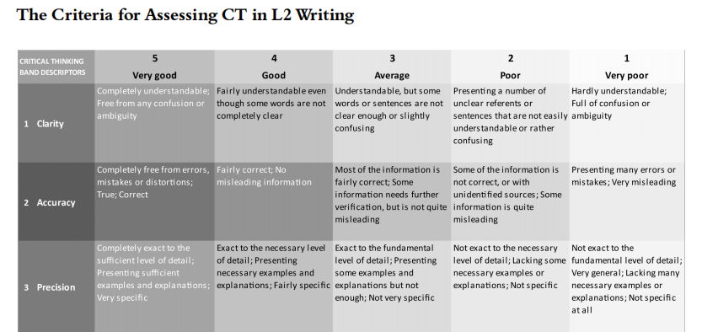
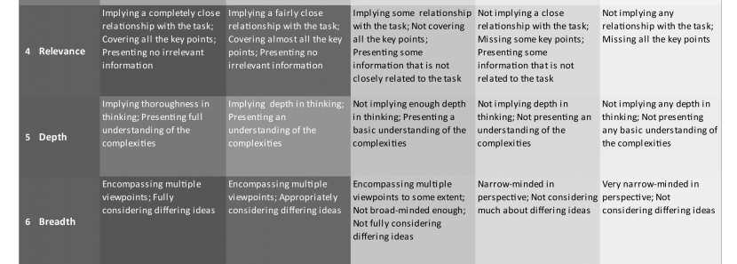
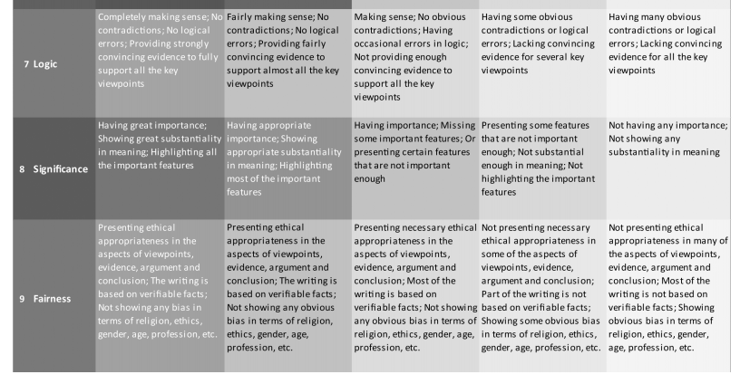

Extension materials
The extension materials that are out with the course textbooks are primarily the aforementioned presentations, model texts, worksheets for students to interrogate models, worksheets to structure students thinking, planning and writing, and worksheets to support self and peer review.

